GB_Landing_Graphic_Spec_v2

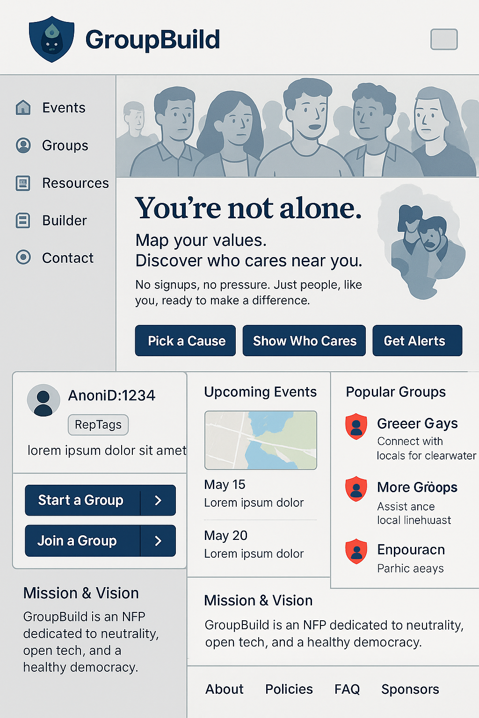
1. First-Impression UX Strategy
Navigation panel shows:
- Site is hyper-active (drop-down list of most active Groups, event map thumbnails)
- Most content accessible without Anon-ID registration
Header sections show:
- Values alignment via a graphic showing protestor faces
- Tagline to validate emotional resonance with dissenters
- Explainer video auto-cycles over graphic after 10 seconds
- Users behave; BeAxa thumbnail animation links to explainer on AI moderation (BeAxa), ScriptTag and RepTag systems that help deprioritize toxicity without censorship
Mid sections show:
- Row of Call-to-Action buttons directing users via Anon-ID registration:
[Explore Groups], [Join A Cause], [Start A Movement], [Find Your People], [Stay Safe]
- Default map region shows North America, with Washington DC as an overlay thumbnail
- Auto-cycling banner shows example Groups (use fake profiles in demo)
Footer Section shows:
- Trust-building links: vision, values, policies, FAQs (5W’s)
- Organization model: governance, staff-ownership, encrypted messaging

2. Layout Overview and Navigation Tree
The landing page uses a split layout with a persistent left-side navigation bar and scrollable main content.
Component | Function
Header (with BeAxa logo) | Branding and site identity, clickable to refresh homepage
Left-Side Navigation | Quick access to: Events, Groups, Resources, Builder, Contact
Map/Hotspots | Defaults to North America, shows protest activity, overlays for DC
Call to Action (CTA) | ‘Pick a Cause’ → ‘Show Who Cares’ → ‘Get Alerts’
AnonID Registration | Generates AnonID linked to avatar + RepTags
Group Functions | Start or join Groups; role-based chats
Event Listings | Sorted by relevance, shows map thumbnails
Popular Groups | Displayed by trust/region
Mission & Vision Blurb | Explains NFP status, neutrality, safe tech
Footer | Org type, safe-messaging app, open source notes, moderation philosophy

3. Icon Labels and Example Text Blocks:
All icons should follow the GroupBuild red-shield SVG convention. Each section includes:
- Title label (e.g. 'Events Near You', 'Start A Group')
- Short phrase or blurb (e.g. 'Connect with locals for clean water')
- Graphic block or thumbnail space for previews, chats, or actions

4. Rick's Graphic Render Prompt:
Render a large composite wireframe image. Use placeholders for maps, fake profiles, BeAxa animation block, and cycling chat banners. Ensure the following are included:
- Left-side nav bar
- Top logo header with protestor image and embedded explainer
- Mid-screen CTA block with 5 buttons
- Default map view (North America with DC overlay)
- Example Group chat ticker (auto-cycling)
- Footer explaining trust, technology, and values

5. Elias' Notes:
- Can we modify the site template around these layout specs?
- Suggest CTA section draw primary focus, followed by map + group ticker.
- We must ensure mobile-first layout, privacy-first defaults, and responsive interaction.
- Prioritization Summary: CTA → Map → Group Feed → Mission → Footer/Resources.

